--=================================================================================
--============================== CIS 310 ASSIGNMENT 6===============================
--=================================================================================
/*
STUDENT NAME: Maria Riley
STUDENT ID: 5490253
SUBMISSION DATE: 3/7/25
*/
-- 1. Execute the script for the StayWell database (from Database Chapter 1 file folder) in Microsoft SQL Server to create and populate the database. (10 pts)
Create an entity relationship diagram for the StayWell database in Microsoft SQL Server. You must connect the tables with proper relationships, below example screenshot do not contain the answer. Use the given data and your learning from database designs, to determine which table is on the one side and which is on the many side in each relationship. *Reminder, the shared attribute/column names can be different on the connecting tables.
Use a tool such as Snipping Tool to screen capture the ERD and paste it here.
Your screenshot must show connection to YOUR database, as shown in example or will receive 0.
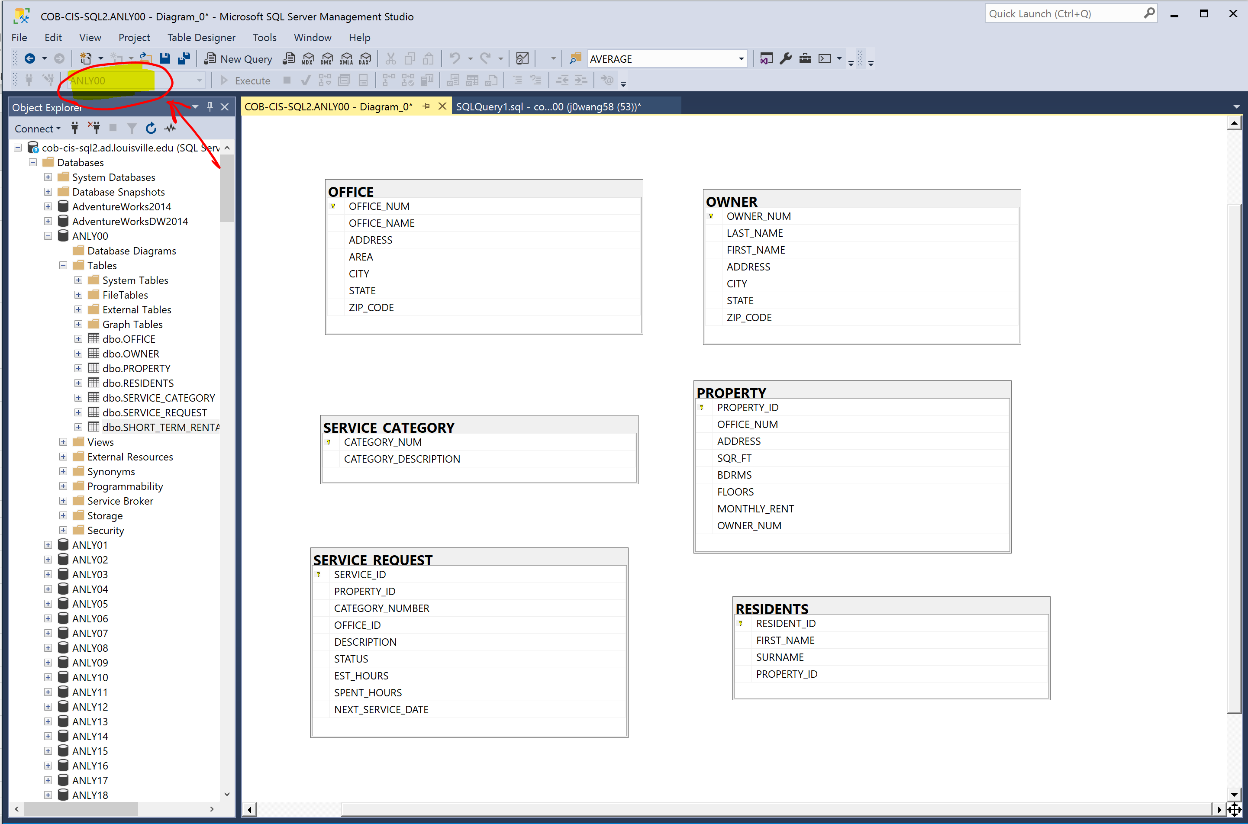

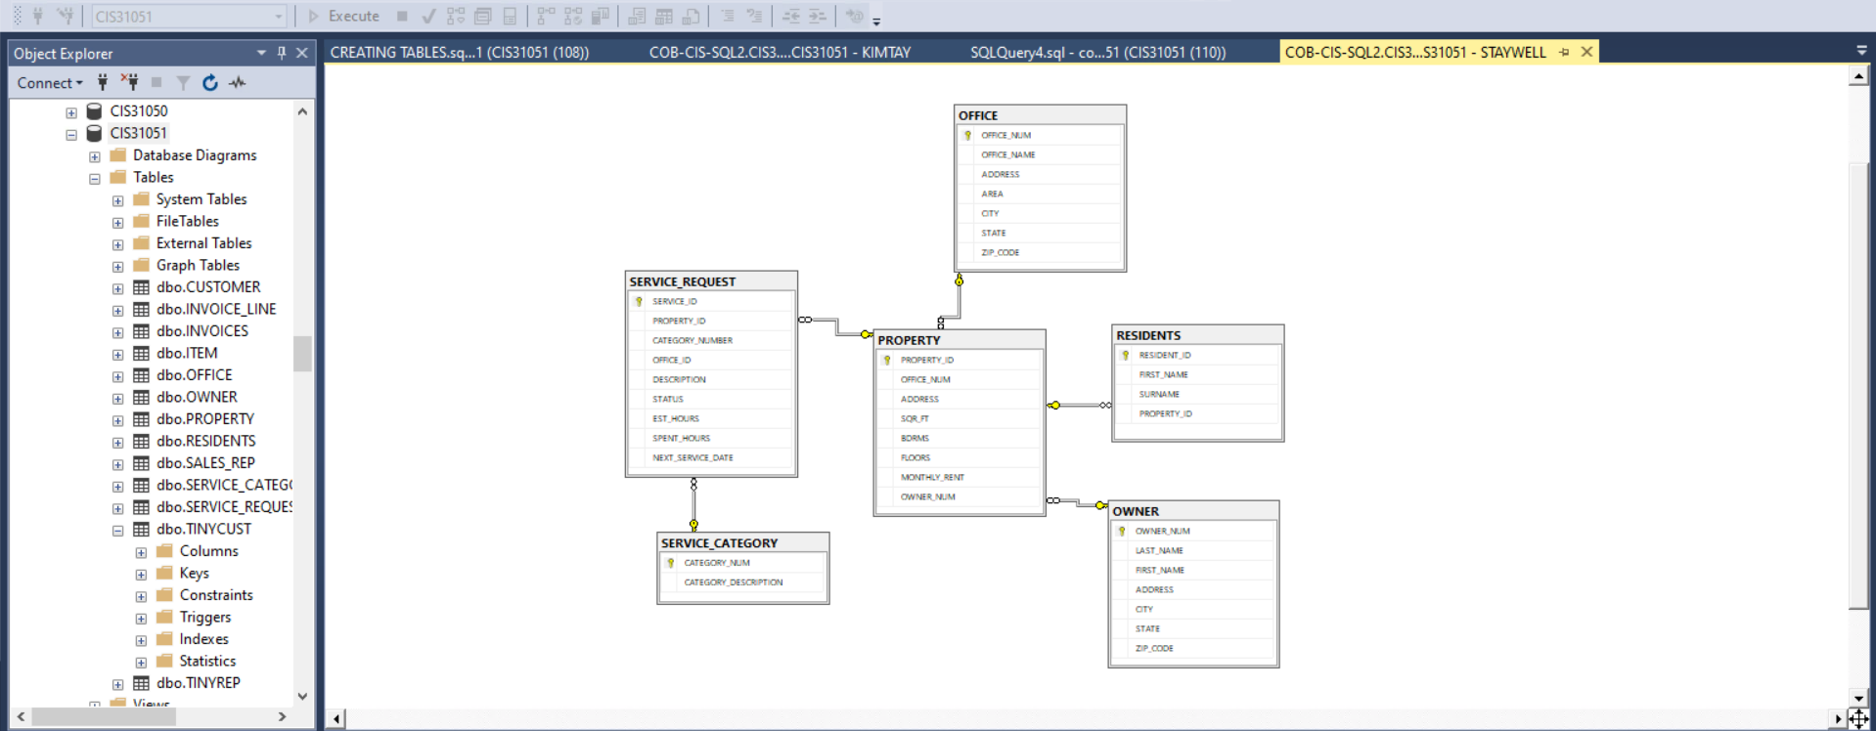

--2. Provide the SQL script for creating a SHORT_TERM_RENTAL table with the structure shown below,
PROPERTY_ID should be the only Primary Key for this table. (5 pts)

/*
==Column Name== | ==Data Type===
| PROPERTY_ID | NUMERIC
| OFFICE_NUM | NUMERIC
| ADDRESS | VARCHAR(30)
| SQR_FT | NUMERIC
| BDRMS | DECIMAL(2, 0)
| FLOORS | INT
| WEEKLY_RENT | NUMERIC
| OWNER_NUM | CHAR(5)
*/
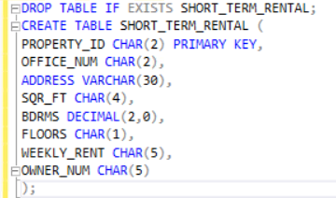

--3. Provide a screenshot of SHORT_TERM_RENTAL table's metadata. (5 pts)
--Your screenshot should show all 8 rows and the first 8 columns, and your username CIS310XX at the bottom. Example as below:
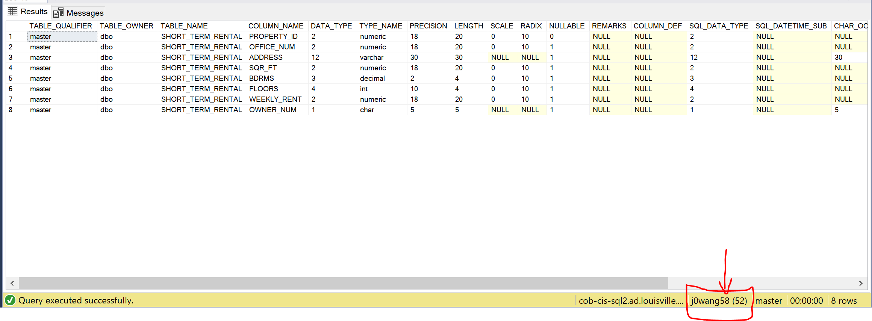
--*Reminder: In Microsoft SQL Server, you may execute "EXEC SP_COLUMNS Tablename;" command to see the metadata (data about the data). in the output, (where Tablename is the name of the table whose structure/metadata you want to show.)
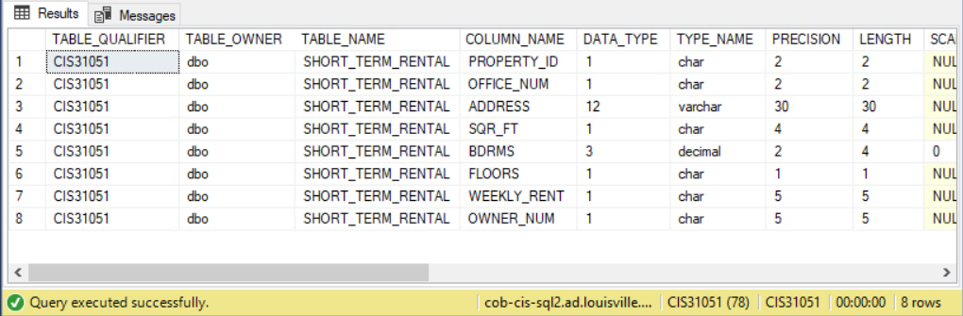

--4. Provide the SQL script for inserting below record to the SHORT_TERM_RENTAL table. (2 pts)
--* Reminder that text type data should be encased in the appropriate symbols.
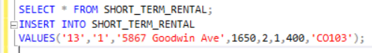

--5. Provide the SQL script for deleting SHORT_TERM_RENTAL table from the SQL server. (2 pts)

--6. Provide the SQL scripts to output the metadata of the STAYWELL tables. (3 pts)
Note that there are 6 tables. Therefore, there should be 6 statements.
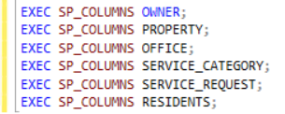

--7. Provide the SQL scripts to output the contents (all columns and rows) of the STAYWELL tables. (3 pts)
Note that there are 6 tables. Therefore, there should be 6 statements.
