#CIS343-01
#Program 3
#Due Date: 11-17-25
#Program loads car data from a CSV file and builds 4 linear regression models.

#importing the necessary libraries
import pandas
import matplotlib.pyplot as plt
from scipy import stats

#using the provided CSV file to load the data
filename = "car_data.csv"
data = pandas.read_csv(filename)
print("\nfirst few rows:")
print(data.head())

#using the function for regression, plotting, and summary
def regression_analysis(x, y, xlabel, ylabel, testvalue=None):

slope, intercept, rval, pval, std_err = stats.linregress(x, y)

#plot scatter + regression line
plt.figure(figsize=(8, 5))
plt.scatter(x, y, color='green', label='data points')
plt.plot(x, intercept + slope * x, color='red', label='linear regression')
plt.title(f"{ylabel} vs {xlabel}")
plt.xlabel(xlabel)
plt.ylabel(ylabel)
plt.legend()
plt.grid(True)
plt.show()

#displaying the model statistics
print(f"\nregression analysis: {ylabel} vs {xlabel}")
print(f"slope: {slope:.4f}")
print(f"intercept: {intercept:.4f}")
print(f"r squared: {rval**2:.4f}")
print(f"p-value: {pval:.4e}")
print(f"standard error: {std_err:.4f}")

#developing the prediction
if testvalue is not None:
test2value = intercept + slope * testvalue
print(f"predicted {ylabel} for {xlabel} = {testvalue}: {test2value:.2f}")
else:
test2value = None

return rval**2, pval, slope, intercept, test2value

#creating each of the 4 regression models
#engine displacement to predict price
r2_1, p1, s1, i1, pred1 = regression_analysis(data['car_engine_displacement'],
data['car_price'],
"engine displacement (cc x1000)",
"car price",
testvalue=2.5
)
#mileage to predict price
r2_2, p2, s2, i2, pred2 = regression_analysis(data['car_mileage'],
data['car_price'],
"mileage",
"car price",
testvalue=108567
)
#top speed to predict price
r2_3, p3, s3, i3, pred3 = regression_analysis(data['car_top_speed'],
data['car_price'],
"top speed",
"car price",
testvalue=189
)
#maintenance interval to predict price
r2_4, p4, s4, i4, pred4 = regression_analysis(data['car_maintenance_interval'],
data['car_price'],
"maintenance interval",
"car price",
testvalue=15000
)

#using the models to create a comparison summary
summary = pandas.DataFrame({
"model": ["Engine Displacement","Mileage","Top Speed","Maintenance Interval"],
"R²": [r2_1, r2_2, r2_3, r2_4],
"p-value": [p1, p2, p3, p4]
})

print("\nmodel summary")
print(summary.sort_values(by="R²", ascending=False))

#using result to create real-world summary
print("\nreal-world interpretation")
if p1 > 0.05:
print("the engine displacement isn't statistically significant so the engine size doesn't strongly influence price")
else:
print("the engine displacement is statistically significant so larger engines most likely influence price")

if p2 < 0.05:
print("the mileage is statistically significant so higher mileage most likely lowers price")

if p3 < 0.05:
print("the top speed is statistically significant so faster cars will most likely cost more")

if p4 < 0.05:
print("maintenance interval is statistically significant so cars that go longer between services will most likely cost more")

#using the result to determine which model is the strongest predictor
best_model = summary.sort_values(by="R²", ascending=False).iloc[0]
print(f"\nstrongest predictor: {best_model['model']} (R² = {best_model['R²']:.3f})")

Output:

first few rows:
car_price car_year car_mileage car_maintenance_interval \
0 8827.635000 2006 95084 11655
1 10247.700000 2019 174695 13173
2 10057.998333 2014 12392 9495
3 10664.093333 2010 60680 15893
4 8607.801667 2007 182789 27386

car_engine_displacement car_weight car_seats car_top_speed
0 4.83 1793 4 182
1 3.71 1248 5 174
2 2.93 1046 2 234
3 2.97 2144 2 172
4 1.33 1213 4 176
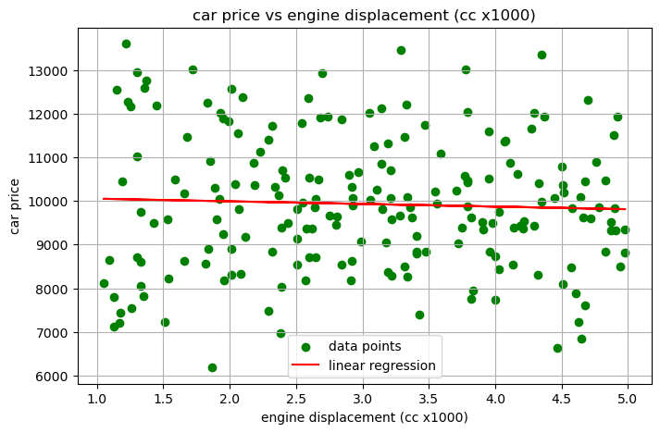

regression analysis: car price vs engine displacement (cc x1000)
slope: -60.5566
intercept: 10113.8495
r squared: 0.0020
p-value: 5.3157e-01
standard error: 96.6266
predicted car price for engine displacement (cc x1000) = 2.5: 9962.46
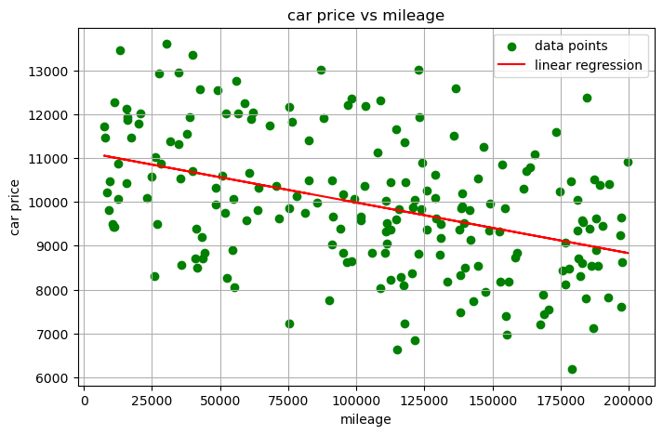

regression analysis: car price vs mileage
slope: -0.0115
intercept: 11139.9594
r squared: 0.1817
p-value: 3.1106e-10
standard error: 0.0017
predicted car price for mileage = 108567: 9886.45
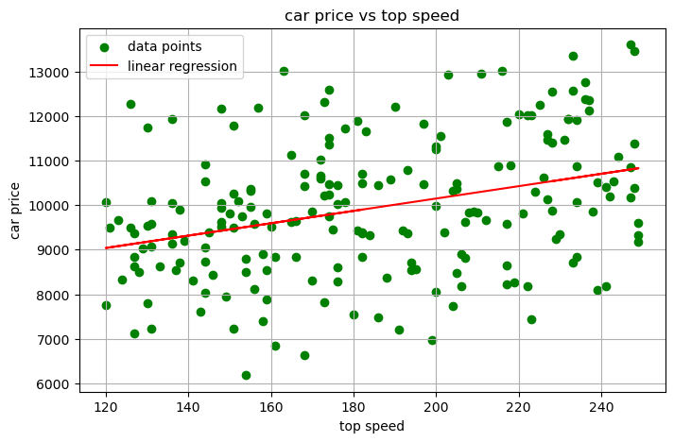

regression analysis: car price vs top speed
slope: 13.8859
intercept: 7371.7553
r squared: 0.1143
p-value: 9.8228e-07
standard error: 2.7476
predicted car price for top speed = 189: 9996.19
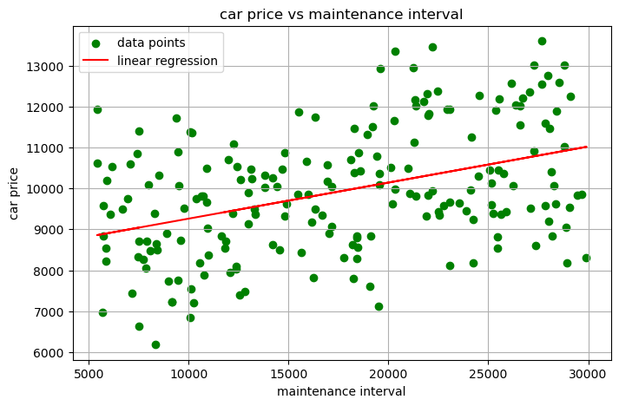

regression analysis: car price vs maintenance interval
slope: 0.0881
intercept: 8381.3079
r squared: 0.1723
p-value: 9.8954e-10
standard error: 0.0137
predicted car price for maintenance interval = 15000: 9702.96

model summary
model R² p-value
1 Mileage 0.181692 3.110633e-10
3 Maintenance Interval 0.172282 9.895422e-10
2 Top Speed 0.114255 9.822832e-07
0 Engine Displacement 0.001980 5.315732e-01

real-world interpretation
the engine displacement isn't statistically significant so the engine size doesn't strongly influence price
the mileage is statistically significant so higher mileage most likely lowers price
the top speed is statistically significant so faster cars will most likely cost more
maintenance interval is statistically significant so cars that go longer between services will most likely cost more

strongest predictor: Mileage (R² = 0.182)

