Assignment 3:

Analysis Modeling

Version 1.0
Table of Contents
1. Adjusts Search Results (Use Cases 1 – 3) 3
1.1 Use Case Descriptions 3
1.1.A. Use Case 1: Search Website for Content 3
1.1.B. Use Case 2: View Search Results 4
1.1.C. Use Case 3: Filter Search Results 5
1.2 Associated System Requirements & Traceability Matrix 6
1.2.A System Requirements 6
1.2.B Traceability Matrix 6
1.3 Use Case Diagram 7
1.4 Sequence Diagram 8
1.5 Prototypes 9

2. Blog Posts (Use Cases 24-28)
2.1 Use Case Descriptions 10
2.1.A. Use Case 24: Create Blog Posts 10
2.1.B. Use Case 25: View Blog Posts 11
2.1.C. Use Case 26: Modify Blog Posts 12
2.1.D Use Case 27: Share Blog Posts
2.1.E Use Case 28: Delete Blog Posts
2.2 Associated System Requirements & Traceability Matrix 15
2.2.A System Requirements 15
2.2.B Traceability Matrix 15
2.3 Use Case Diagram 16
2.4 Sequence Diagram 17
2.5 Prototypes 18
3. Class Diagram 19

1. Adjusts Search Results (Use Cases 1 – 3)

1.1 Use Case Descriptions:

1.1.A. Use Case 1: Search Website for Content

Use Case Name: Search Website for Content | ID: 1 | Importance Level: High
Primary Actor: User |  | Use Case Type: Essential, Overview
Stakeholders and Interests:

- Users: wants to quickly locate relevant information on the site.
- Administrators: want efficient search to encourage engagement and accessibility.
Brief Description: This use case describes how a user initiates a search request to find website content such as blog posts, event pages, or resources.
Trigger: User enters a keyword or phrase in the website search bar.
Relationships:
Association: Between user and system interface.
Include: View Search Results (automatically follows).
Extend: Can extend to Filter Search Results if user refines the query.
Generalization:
Normal Flow of Events:

- User navigates to the website homepage or search page.
- User enters a search term in the search bar.
- System validates the input and queries the database.
- System retrieves relevant content and displays the results page.

SubFlows:

3a. If search input is empty, prompt user to enter a valid term.
Alternate/Exceptional Flows:

4a. If no results match, system displays “No Results Found” and offers related suggestions.

1.1.B. Use Case 2: View Search Results

Use Case Name: View Search Results | ID: 2 | Importance Level: High
Primary Actor: User |  | Use Case Type: Detail, Real
Stakeholders and Interests:

- Users: need clear, accurate, and sortable results.
- Administrators: want to ensure relevant and optimized search rankings.
Brief Description: Displays the results generated from a search query, including titles, summaries, and links to full content.
Trigger: Initiated when search results are retrieved.
Relationships:
Association: Linked to Search Website for Content.
Include:
Extend: Filter Search Results.
Generalization:
Normal Flow of Events:

- System presents a list of matching content.
- Each result shows a title, summary, category, and link.
- User scrolls or navigates between result pages.
- User selects a result to open the full content page.

SubFlows:

3a. User can sort results (e.g., by date, relevance, or category).
Alternate/Exceptional Flows:

1a. If server response fails, display “Error loading results—please try again.”

1.1.C. Use Case 3: Filter Search Results

Use Case Name: Filter Search Results | ID: 3 | Importance Level: Medium
Primary Actor: User |  | Use Case Type: Detail, Real
Stakeholders and Interests:

- Users: wants to refine large result sets for easier browsing.
- Administrators: want filters to improve user experience and reduce bounce rate.
Brief Description: Allows users to refine their search results by selecting filters such as date, category, (Event, Blog, Service), or relevance.
Trigger: User applies one or more filters after viewing search results.
Relationships:
Association: Between user and system interface.
Include:
Extend: Extends View Search Results.
Generalization:
Normal Flow of Events:

- User selects desired filters from the sidebar or dropdown.
- System applies filters to current search results.
- Filtered results are displayed dynamically.

SubFlows:

1a. User can clear or adjust filters to broaden the search again.
Alternate/Exceptional Flows:

2a. If no results fit the filter, a “No results for selected filer” message is shown.

1.2 Associated System Requirements & Traceability Matrix:

1.2.A System Requirements

- SR001: The search bar will allow content to be searched for.
- SR002: The search bar will allow relevant pages to be viewed based on searches.
- SR003: The search bar will allow search results to be filtered.

1.2.B Traceability Matrix

 | Search Website for Content | View Search Results | Filter Search Results
SR001: The search bar will allow content to be searched for. | X
SR002: The search bar will allow relevant pages to be viewed based on searches. |  | X
SR003: The search bar will allow search results to be filtered. |  |  | X

1.3 Use Case Diagram

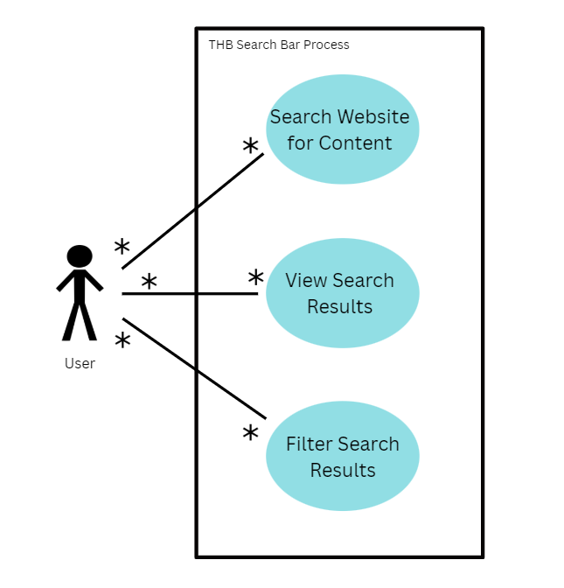

This diagram illustrates how a user interacts with The Hope Buss website to locate information efficiently. The user initiates actions by searching for content, viewing the resulting pages, and applying filters to narrow down results. These interactions connect directly to The Hope Buss system, which processes user input, retrieves relevant information from the database, and returns refined results. Overall, the diagram emphasizes the system’s role in providing a smooth, user-centered search experience that supports accessibility and engagement.

1.4 Sequence Diagram

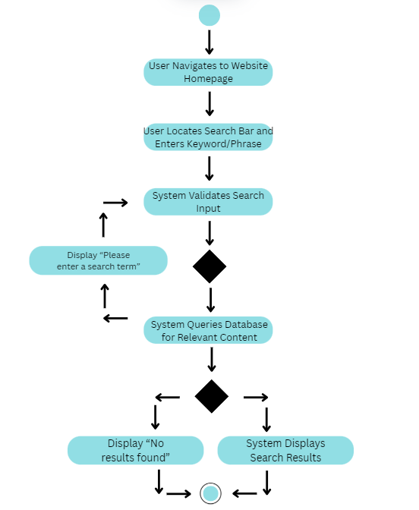

1.5 Prototypes

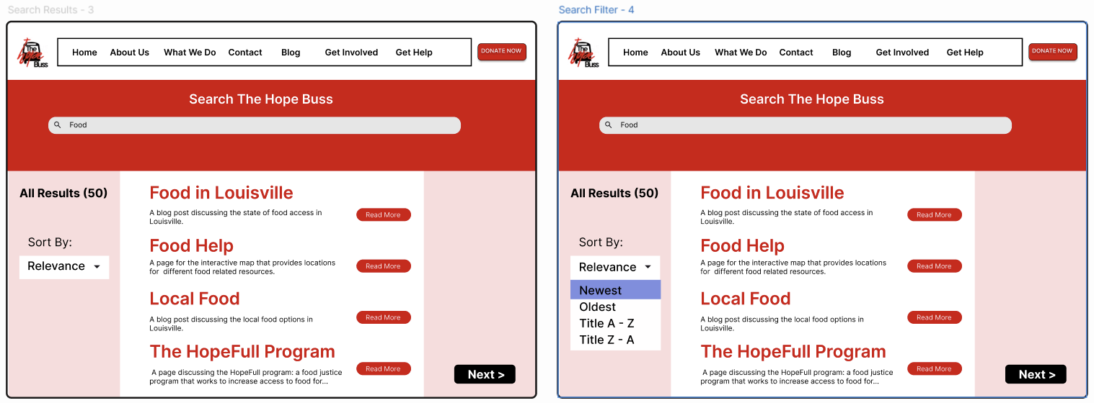

2. Blog Posts (Use Cases 24 - 28)

2.1 Use Case Descriptions:

2.1.A. Use Case 24: Create Blog Posts

Use Case Name: Create Blog Posts | ID: 24 | Importance Level: High
Primary Actor: Administrator |  | Use Case Type: Detail, Real
Stakeholders and Interests:

- Users: expect timely, accurate updates about nonprofit activities.
- Administrators: need to post new content to inform and engage the public.
Brief Description: Describes how administrators add new blog content to the website.
Trigger: Administrator selects “Create New Post” from the dashboard.
Relationships:
Association: Between administrator and CMS interface.
Include: View Blog Posts after creation for review.
Extend:
Generalization:
Normal Flow of Events:

- Administrator opens blog management dashboard.
- Administrator clicks “Create Post.”
- Administrator fills out required fields (title, body, tags, images).
- Administrator previews post.
- Administrator publishes post to website.
SubFlows:

3a. Administrator can save draft for later editing.
5a. Administrator can schedule the post for a future publish date.
Alternate/Exceptional Flows:

4a. If validation fails (missing title/content), system displays error and highlights required fields.

2.1.B. Use Case 25: View Blog Posts

Use Case Name: View Blog Posts | ID: 25 | Importance Level: High
Primary Actor: User |  | Use Case Type: Essential, Overview
Stakeholders and Interests:

- Users: want access to readable, informative, and shareable posts.
- Administrators: want content visibility and engagement tracking.
Brief Description: Allows users to view published blog posts through the website interface.
Trigger: User selects “Blog” tab or clicks a post link.
Relationships:
Association:
Include: Share Blog Posts (optional).
Extend: Filter Search Results (if browsing by category or tag).
Generalization:
Normal Flow of Events:

- User navigates to “Blog” tab.
- System retrieves and lists published posts in reverse chronological order.
- User selects a post to view its full content.
- System displays post details, author, date, and social sharing buttons.

SubFlows:

3a. User can navigate to next or previous post.
Alternate/Exceptional Flows:

2a. If no posts exist, system displays “No posts available at this time.”

2.1.C. Use Case 26: Modify Blog Posts

Use Case Name: Modify Blog Posts | ID: 26 | Importance Level: High
Primary Actor: Administrator |  | Use Case Type: Detail, Real
Stakeholders and Interests:

- Users: expect accurate and up-to-date information.
- Administrators: need to correct, update, or enhance existing content.
Brief Description: Describes how administrators edit existing blog posts.
Trigger: Administrator selects “Edit Post” on a blog post within the CMS.
Relationships:
Association: Between administrator and CMS interface.
Include: View Blog Posts.
Extend:
Generalization:
Normal Flow of Events:

- Administrator logs in and selects a post to edit.
- System displays current post content in an editable form.
- Administrator makes updates (text, images, metadata).
- Administrator previews the updated post.
- Administrator saves and republishes changes.

SubFlows:

5a. System tracks revisions and archives older versions.
Alternate/Exceptional Flows:

3a. If user lacks permission, system denies access and logs the attempt.

2.1.D. Use Case 27: Share Blog Posts

Use Case Name: Share Blog Posts | ID: 27 | Importance Level: Medium
Primary Actor: User |  | Use Case Type: Detail, Real
Stakeholders and Interests:

- Users: want to share valuable information with others easily.
- Administrators: want greater reach and visibility for the nonprofit’s message.
Brief Description: Enables users to share blog content via social media or email.
Trigger: User clicks “Share” button on blog post.
Relationships:
Association:
Include:
Extend: View Blog Posts.
Generalization:
Normal Flow of Events:

- User clicks on a “Share” icon (e.g., Facebook, X, Email).
- System opens a share dialog or external link.
- User confirms the share.
- System posts or sends the link to the selected platform.
SubFlows:
Alternate/Exceptional Flows:

7a. If the external platform is unavailable, display an error message and offer to copy the link manually.

2.1.E. Use Case 28: Delete Blog Posts

Use Case Name: Delete Blog Posts | ID: 28 | Importance Level: Medium
Primary Actor: Administrator |  | Use Case Type: Detail, Real
Stakeholders and Interests:

- Users: rely on relevant, accurate information.
- Administrators: need to remove outdated or inappropriate content.
Brief Description: Describes how administrators permanently delete a blog post.
Trigger: Administrator selects “Delete” in the CMS interface.
Relationships:
Association: Between administrator and CMS interface.
Include:
Extend: May trigger View Blog Posts for confirmation.
Generalization:
Normal Flow of Events:

- Administrator logs into CMS.
- Administrator navigates to the post management list.
- Administrator selects the post and clicks “Delete.”
- System asks for confirmation.
- Administrator confirms deletion.
- System removes the post and updates the post list.

SubFlows:

14a. System archives deleted post for recovery within a limited period.
Alternate/Exceptional Flows:

13a. If administrator cancels confirmation, post remains published.
15a. If database error occurs, display “Deletion failed—please retry.”

2.2 Associated System Requirements & Trace Matrix:

2.2.A System Requirements

- SR021: The blog will allow posts to be created.
- SR022: The blog will allow posts to be viewed.
- SR023: The blog will allow posts to be modified.
- SR024: The blog will allow posts to be deleted.
- SR025: The blog will allow posts to be shared.

2.2.B Traceability Matrix

 | Create Blog Posts | View Blog Posts | Modify Blog Posts | Share Blog Posts | Delete Blog Posts
SR021: The blog will allow posts to be created. | X
SR022: The blog will allow posts to be viewed. |  | X
SR023: The blog will allow posts to be modified. |  |  | X
SR024: The blog will allow posts to be deleted. |  |  |  |  | X
SR025: The blog will allow posts to be shared. |  |  |  | X

2.3 Use Case Diagram

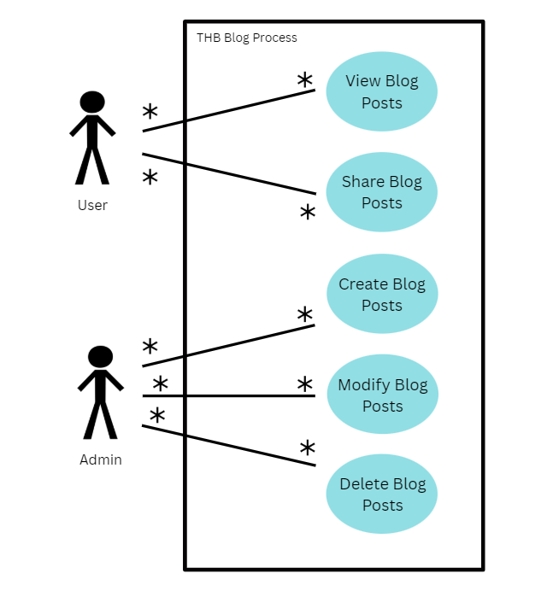

This diagram represents how both users and administrators interact with The Hope Buss website’s blog system. Users can view and share published blog posts, engaging with the organization’s stories and community updates. Administrators manage the backend functions (creating, editing, and deleting posts) to ensure the blog remains current and accurate. All interactions flow through The Hope Buss system, which handles content storage, publishing, and visibility. Together, these processes highlight how the blog feature supports community engagement while maintaining administrative control and consistency across the site.

2.4 Sequence Diagram

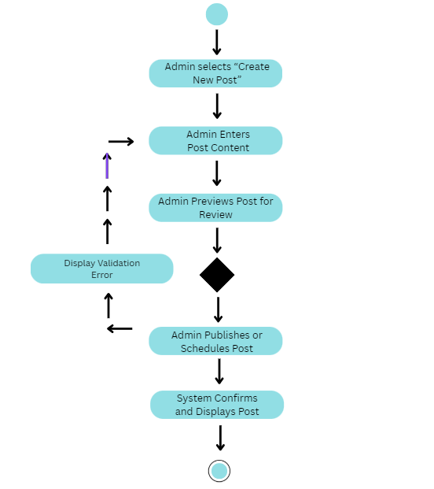

2.5 Prototypes

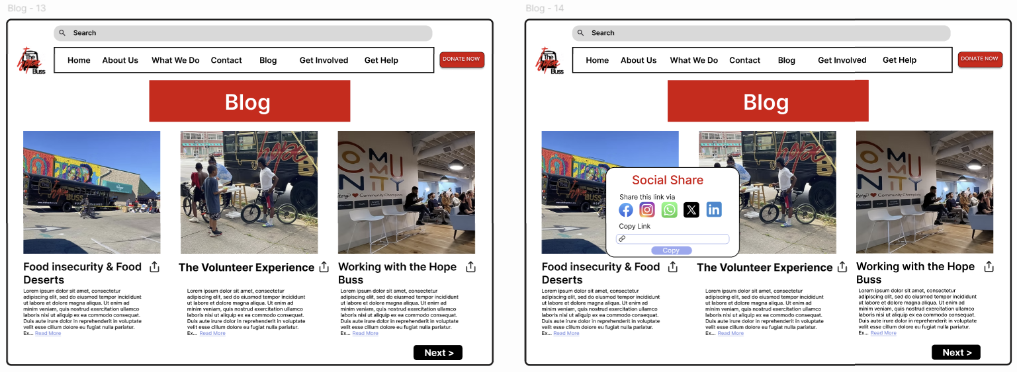

3. Class Diagram

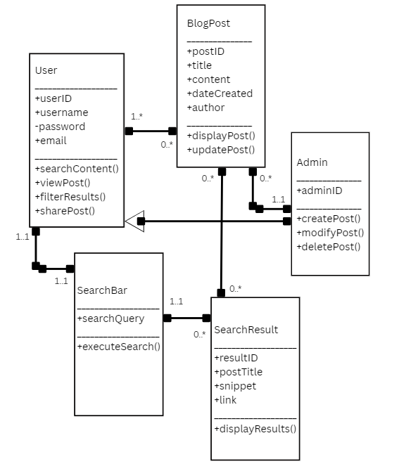

This class diagram models the website’s user interactions and administrative functions. The user class represents general visitors who can search, filter, view, and share blog posts. Admin, a specialized type of user, can create, modify, and delete posts, emphasizing role-based privileges. Search bar and search result classes handle user queries and display relevant outcomes. The blog post class represents website content, linking to both users and search results. Relationships and multiplicities illustrate user-to-content interactions and administrative control within the system.

